**New Skill I learned**

For my program, I had to implement a timer for the test, to countdown and calculate the score of the user. This feature wasn’t taught in the advanced higher course so I had to research ways to do it myself.

**Timer**

I found that the best way to do this is using a setInterval function, with a callback function when it’s finished. setInterval is a function that is executed repeatedly with a fixed delay between each call. When a “callback()” is called, the timer will stop and return to where it was called from. This effectively makes it so a setInterval with a delay of 1000 milliseconds will act as a per second timer. I used this to create a timer with 1000 milliseconds, which will update the time value each time it is called. When the test is finished, it sends a callback to the function, which will stop the test and move on to calculate scores and display the finish screen.

References

<https://developer.mozilla.org/en-US/docs/Web/API/WindowOrWorkerGlobalScope/setInterval>

<https://stackoverflow.com/questions/30427882/make-a-timer-using-setinterval>

Evidence

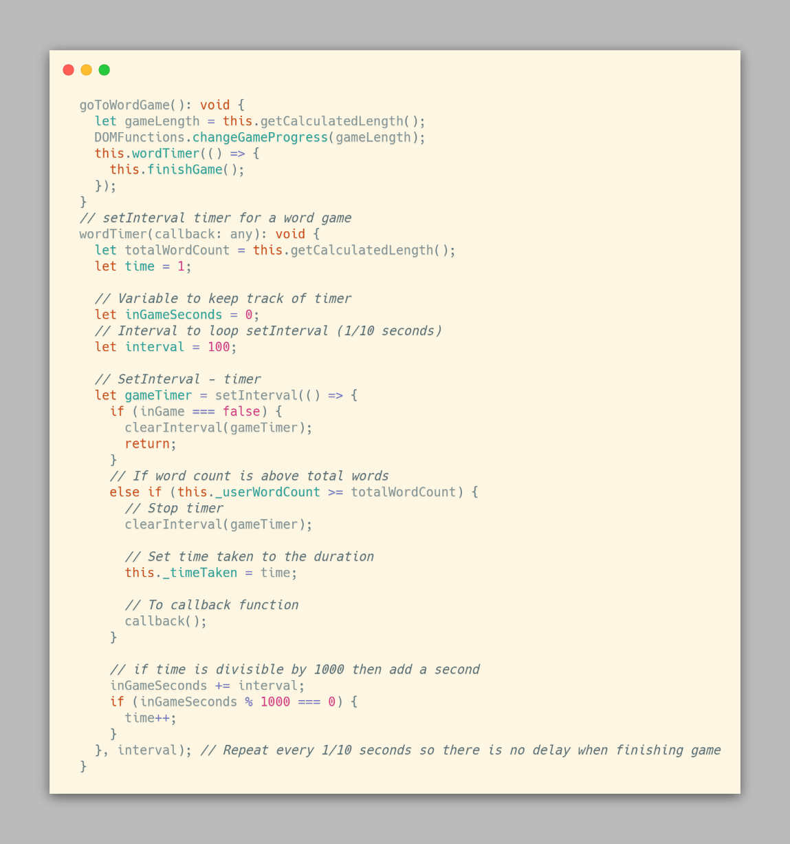

**Ongoing Testing**

|  |  |  |  |
| --- | --- | --- | --- |
| Test | Outcome | Solution | Reference |
| Previous word highlighting | Not working | Only highlight second/third word so it doesn't go to a value of -1 |  |
| Line deletion when you get to end of line | Deleting every word instead of a row | Use offsetTop(container) instead of getBoundingClientRect(window) | <https://developer.mozilla.org/en-US/docs/Web/API/HTMLElement/offsetTop> |
| Displaying words typed in the countdown | changing every second instead of when a word is typed | Put the counter in wordCount instead of the setInterval loop | MDN Web docs |
| Buttons changing settings | Buttons don't do anything | convert the variables to int, instead of a string "0" for example |  |
| Submit button works properly | Submit button will reload the page | Add return false to the end, so it doesn't refresh | Stack overflow |
| LocalStorage will save a score | LocalStorage can't store the user score | Data needs to be parsed into string format, and deparsed later | https://developer.mozilla.org/en-US/docs/Web/API/Window/localStorage |
| LocalStorage will save scores properly | LocalStorage breaks with 0 scores | Add a condition to check the length of localStorage is above 0 |  |
| Socreboard will update with new scores | Scoreboard looks for an undefined value | Set the key to search to index - 1 as the length is 1 based, while the array is 0 based |  |
| Bubble sort sorts properly | Program freezing | Bool checking if data is still being swapped had to be strongly compared with === |  |
| View word button works correctly | returns TypeError: "x" is not a function | Change onclick function to be different from the ID | https://developer.mozilla.org/en-US/docs/Web/JavaScript/Reference/Errors/Not_a_function |
| Submitting your name works properly | If name is empty, it is stored empty | Add a dummy name "Anon" for anonymous users | https://developer.mozilla.org/en-US/docs/Web/API/Node/textContent |
| LocalStorage will save settings | LocalStorage doesn't work with settings | Instead of the scoreboard working from length of localStorage, make it work from its own counter |  |

Component testing

|  |  |  |  |
| --- | --- | --- | --- |
| Test | Component | Description | Successful? |
| C1 | Sidebar buttons | Check that the buttons open the sidebar properly. This should disable the rest of the screen from being able to be clicked | Yes |
| C2 | Settings input validation | The selection boxes work as intended. The test/time should gray out depending on which is selected | Yes |
| C3 | View words validation | The alphabetical, length and frequency sort work as intended, and sort the words in the correct order | Yes |
| C4 | Scoreboard validation | The scoreboard displays properly, and sorts user scores properly | Yes |
| C5 | Settings validation | Form will submit when submit button is pressed | Yes |
| C6 | Test run validation | 1. Typing field works properly and will delete word after spacebar is typed 2. Game countdown works properly, will start counting down when you start typing and will count down accordingly 3. Words will highlight red or green depending on if the word is correct | Yes |
| C7 | Test finish validation | WPM and Accuracy will display correctly, Name input box will save input on reload, retry/exit buttons work properly | Yes |

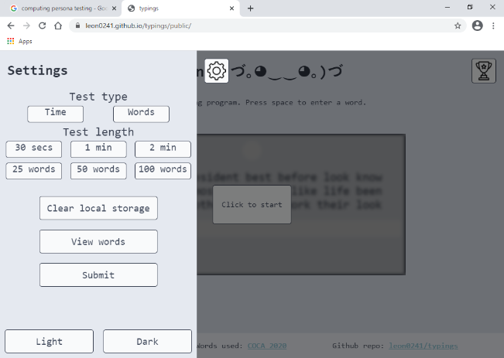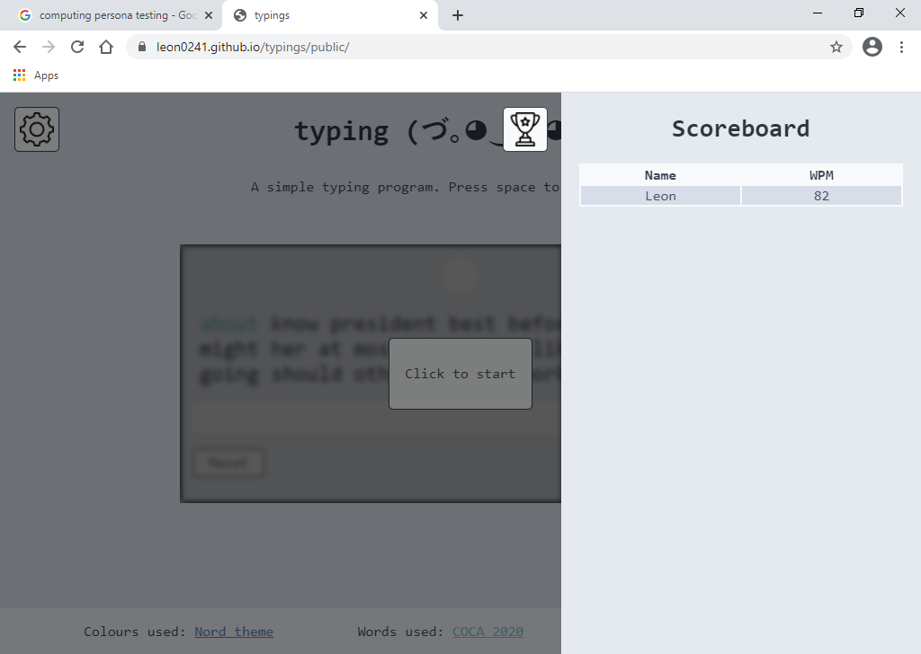Component test – C1

Component test – C2

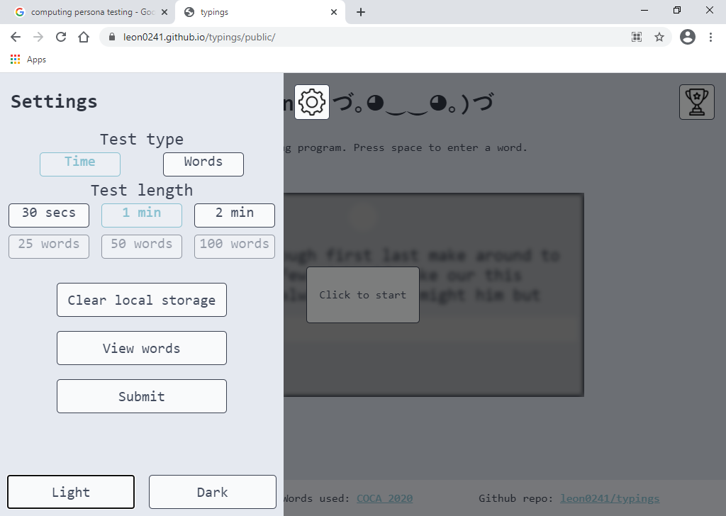

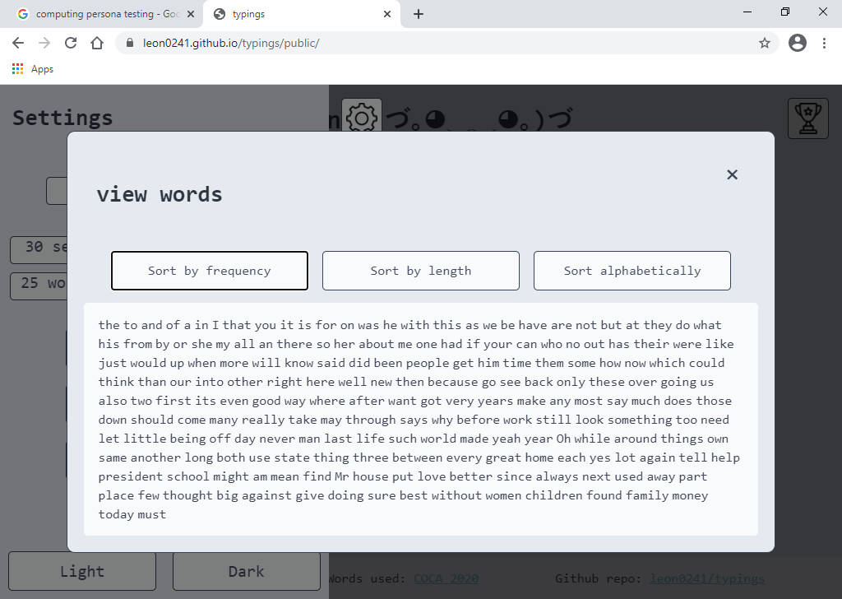Component Test – C3

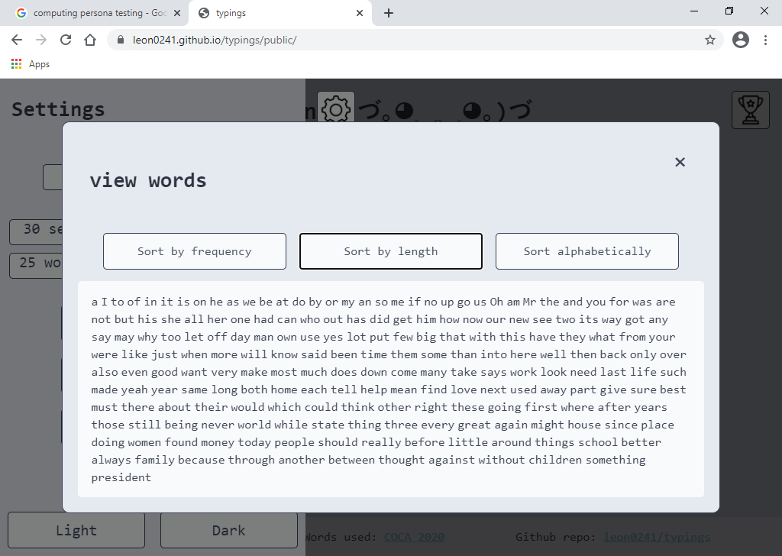

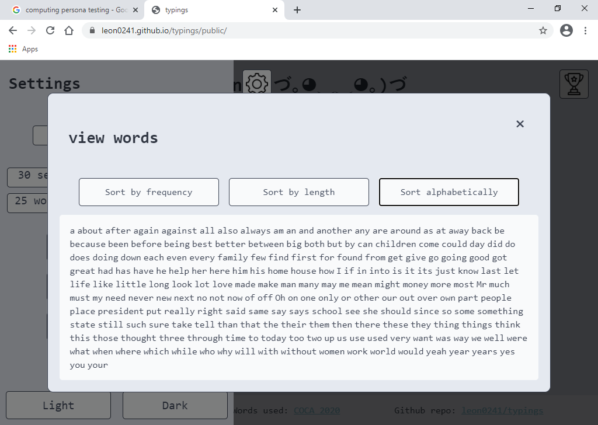Component Test – C3

Component Test – C4

Integration Testing

|  |  |  |  |
| --- | --- | --- | --- |
| Test | Component | Description | Successful? |
| I1 | Settings work properly | Settings will work properly on submit, and update the site even after reload | Yes |
| I2 | Program works properly | Program will run through, and save a user score into localStorage | Yes |
| I3 | Scoreboard displays and sorts properly | Scoreboard will display all user submitted scores sorted from the highest wpm down | Yes |
| I4 | Clear local data works properly | Clearing local storage will remove any user preferences, and scores | Yes |